**MIDTERM PROJECT**

**Stefan Grulović**

**Hristos Hristodoulou**

**Computer Science 205: Business Data Management**

**Fall 2016**

**PRESENTATION**

This application is supposed to help better organize a construction company. The construction company has 50 workers employed who work on 10 different projects that this company undertakes. The application is built to help the company owners find specific information about their workers in order to help them decide what is their next move.

**TABLE DESCRIPTION**

The table contains 14 columns and it mostly focused on information related to the employees. They are:

**EMP_ID** containing the employees id

**NAME** containing the emplyees name with the title (Ms. or Mr.)

**ADDRESS** containing the employees current address of living

**HIRE_DATE** containing the employees hire date in DD/MONTH/YYYY format

**ABSENCES** containing the employees absence information which can be Always,

Almost always, Frequently, Sometimes, Rarely, Almost never and Never

**PHONE**_# containing the employees current phone number

**JOB_ID** containing the employees job id

**JOB_DESCP** containing the employees job description

**HOURLY_PAY** containing the employees hourly pay

**PROJ_ID** containing the employees currently assigned project id

**PROJ_TYPE** containing the employees currently assigned project description

**DATE_STARTED** containing the employees date started working on the specific project

they are assigned

**REGION** containing the employees/project region in id form it can be:

R01 located in North East

R02 located in North West

R03 located in Center East

R04 located in Center West

R05 located in South East

R06 located in South West

**MAN_HOURS** containing the employees man hours put into a specific project

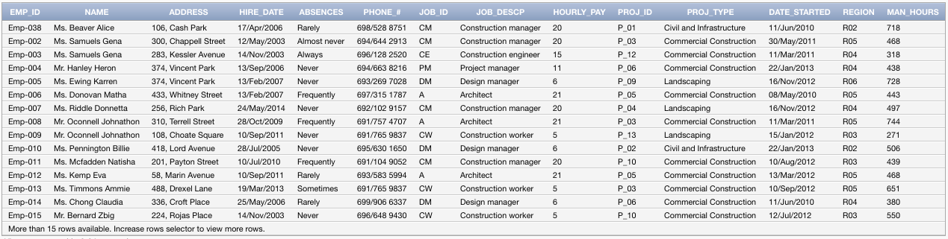

**QUERIES**

1) Shows the general information about the workers, their name, phone number, address, date hired, job description and their current project id.

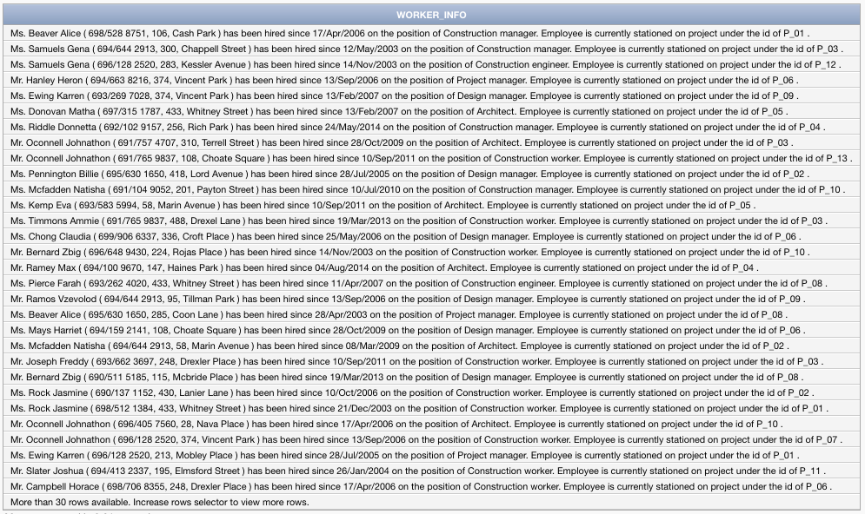

2) Shows the number of employees the company has in a specific job.

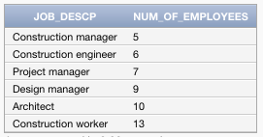

3) Number of employees hired in each year

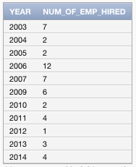

4) Displays all the employees working on a specific job and specific lower limit of the hire date

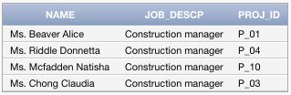

5) Displays the workers that have a high pay check and high absence count

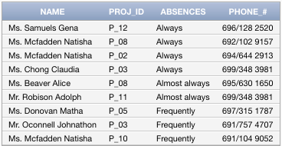

6) Displays the sum of all the workers pay within a specific project

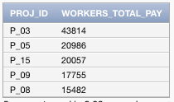

7) Displays the workers average pay within each of the projects

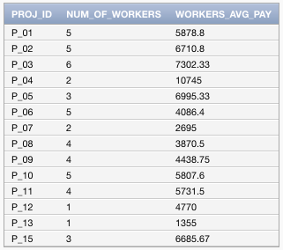

8) Displays the amount of current undertaking project within each location

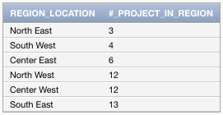

9) Displays all the project where the cost is high and also displays the number of workers working on that project with their cost

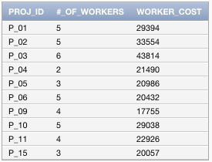

10) Displays the employee’s id, name, months passed from hiring and months passed from being assigned to a specific project, sorted by the employees title

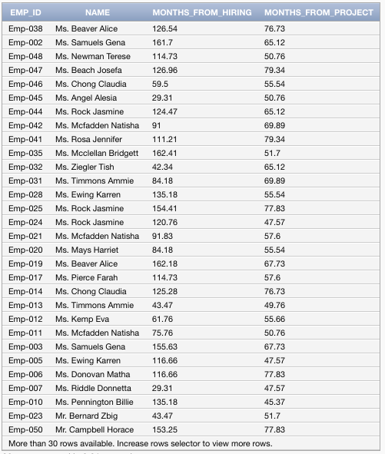

**SUGGESTIONS FRO FURTHER DEVELOPMENT**

The way the the application can be further expanded is by adding more data that can be processed with more queries.